James Keeler

How to install and configure the operating environment for the FitNet system.

Installation Manual

FitNet System

# Introduction

This manual is intended to be used when initially setting up the environment in which the FitNet software will run. The scope of this document is installation of the software and configuration of the operating environment. If the procedures outlined here are not followed, unexpected errors might occur and the software might not function as expected, or at all.

# Prerequisites

The FitNet software is capable of running on either Windows or Linux operating systems. The software has been tested on Windows 7, Windows Server 2008 R2, and Ubuntu 12.04.

# GENI Environment

(Information from the GENI website)

|  |  |
| --- | --- |
| This section tells you how to Sign Up for a GENI account using the GENI Experimenter Portal. The portal is a web interface to the GPO Clearinghouse that manages GENI experimenters, projects and slices. This account will provide you with the right credentials for using the GENI testbed.  If you already have an [Utah Emulab](http://www.emulab.net/) or a [PlanetLab](https://www.planet-lab.org/)account, you can use those to access GENI. You do not need to apply for another account. | [Login to GENI](https://portal.geni.net/) |

## 1. Login to the Portal

The GENI Portal leverages [InCommon](http://groups.geni.net/geni/wiki/InCommon) to provide single sign-on authentication. If you are affiliated with a US college or University that is a [member of the InCommon federation](http://www.incommon.org/federation/info/all-entities.html), simply login using your usual username and password to activate your GENI account. If you are not affiliated with an [InCommon](http://groups.geni.net/geni/wiki/InCommon) federated institution, you may request a GENI-only login.

## Check if you can use your Institution's account

|  |  |
| --- | --- |
| If you want to check whether you can use your Institution's account to login:   * Go to [the GENI Portal](https://portal.geni.net/)and press the 'Use GENI' button. * Start typing your institution's name and if it is a member it will just show up; select it and press 'Continue'. If it does not appear in the list, read on to the next section. * Pressing 'Continue' will transfer you to the familiar Login Page of your institution. Log in to your institution using your usual username and password. If you get an error after you login please send us [an email](mailto:portal-help@geni.net) with the error you got. * If you successfully login, then follow the instructions in the next page, and press Use GENI'Activate'. **Congratulations, now you have access to the GENI Portal.** Now you need to [join a GENI project](http://groups.geni.net/geni/wiki/SignMeUpPortal#a2.BecomeamemberofaGENIProject). |  |

#### If your Institution is not a member of [InCommon](http://groups.geni.net/geni/wiki/InCommon)

If you were not able to login to the GENI Portal through your Institution, you can request a GENI-only account. In order to do that, please fill out the form to [request a GENI-only account](https://shib-idp.geni.net/geni/request.html).

Once you receive an email verifying that we have created an account for you (this may take awhile), you can follow the [above instructions](http://groups.geni.net/geni/wiki/SignMeUpPortal#CheckifyoucanuseyourInstitutionsaccount) but as your Institution use 'GENI Project Office'.

### Become a member of a GENI Project

### Now you should be able to login to the portal. However, in order to run experiments in GENI you would need to join or create a project. If you are:

### a faculty member

### or a senior technical member in a company or a university

### you can become a Project Lead and [create your own projects](http://groups.geni.net/geni/wiki/SignMeUp#a2b.CreateaGENIProject).

### Everyone else should join a project created by a Project Lead. You can ask any of your collaborators that fit the above criteria to create a project for you [to join](http://groups.geni.net/geni/wiki/SignMeUp#a2a.JoinaGENIProject).

### 2a. Join the GENI Project

After a project is created, you can try and join the project. In order to do that, do the following: 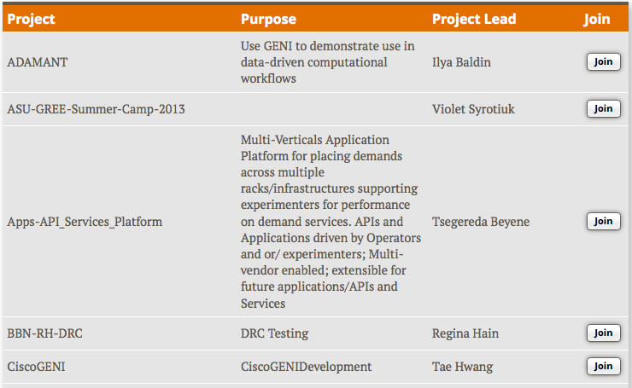

|  |
| --- |
|  |

1. In the *Home tab* click the **Join Project** button.
2. From the list of projects find the one that was created for you or your class and click the **Join** button.   
   Please make sure you select the right name.
3. Congratulations! You have your GENI credentials and you're good to go.

## Log Into Geni Hosts

### Recommend Using Mozzila Firefox.

1. [The FireSSH add-on for Firefox](https://addons.mozilla.org/en-us/firefox/addon/firessh/): Install the FireSSH add-on for Firefox use this as your ssh client. Instructions for using FireSSH <http://firessh.net/help.html>. **\*Recommended\***
2. **Log into Portal.geni.net**
   * **Click on Profile**
   * 
   * **SSH Keys**
   * 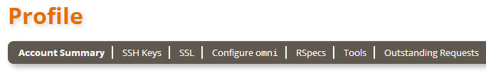

**Note**: You will need your SSH private key on your local machine.

If you generated your SSH keypair on this portal and have not already done so, be sure to:

1. Download your SSH key.
2. After you download your key, be sure to set local permissions on that file appropriately. On Linux and Mac, do

chmod 0600 [path-to-SSH-private-key]

1. When you invoke SSH to log in to reserved resources, you will need to remember the path to that file.
2. Your SSH command will be something like:

ssh -i path-to-SSH-key-you-downloaded [username]@[hostname]

## Create Slice

### Click Create Slice

* + 1. Project Name will be Filled out for the Current project you are on.
    2. Create a Slice Name
    3. Create a Slice Description

### 

### Click Launch Flack

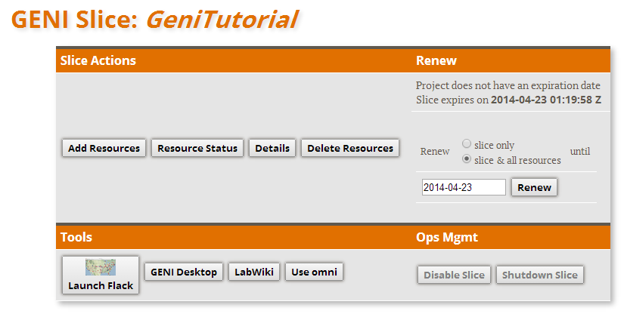

## Flack

### Upon Launching Flack, Flack will authenticate your Credentials and will Start Requesting Geni Aggregates.

### 

### The Green Check Marks Next to each Manager (Aggregate) show that it is available.

### In the Center of the Screen there is an Import Button Click the Down Arrow.

### 

### This Import will Allow us to Setup our Rspec. The Rspec is the Network Topology that we will be setting Up later.

## Create RSPEC.

### Writing OpenFlowv3 request rspecs

* 1. The best way to understand and write OF v3 rspecs is by looking at example rspecs. Keep in mind that the rspec is merely a structured representation of flowspaces that describe the traffic that an experiment wants to control.
  2. This [example rspec](https://openflow.stanford.edu/display/FOAM/rspec), is a complete example. In [this wiki page](http://groups.geni.net/geni/wiki/HowTo/WriteOFv3Rspecs/Examples) you can also find other simpler examples.
  3. In essence your rspec should:

Start with the <rspec> and the <openflow:sliver> tags :

**<?xml version="1.1" encoding="UTF-8"?>**

<rspec xmlns="http://www.geni.net/resources/rspec/3"

xmlns:xs="http://www.w3.org/2001/XMLSchema-instance"

xmlns:openflow="http://www.geni.net/resources/rspec/ext/openflow/3"

xs:schemaLocation="http://www.geni.net/resources/rspec/3

http://www.geni.net/resources/rspec/3/request.xsd

http://www.geni.net/resources/rspec/ext/openflow/3

http://www.geni.net/resources/rspec/ext/openflow/3/of-resv.xsd"

type="request">

<openflow:sliver email="user@geni.net" description="My GENI experiment" ref="http://www.geni.net">

*<!-- rest of rspec -->*

</openflow:sliver>

</rspec>

1. Specify where your controller is running. E.g.:

#!xml

<openflow:controller url="tcp:example.geni.net:9933" type="primary" />

1. Organize the datapaths that are relevant to this sliver within groups. The best way to construct the <openflow:datapath> elements is by copying them from the advertisement rspecs. E.g if [this](http://groups.geni.net/geni/attachment/wiki/HowTo/WriteOFv3Rspecs/ad-sample.rspec) [Download](http://groups.geni.net/geni/raw-attachment/wiki/HowTo/WriteOFv3Rspecs/ad-sample.rspec) is the advertisement rspec, and you want :
2. ports 7 and 20 of datapath with dpid 06:a4:00:12:e2:b8:a5:d0
3. ports 50 and 71 of datapath with dpid 06:af:00:24:a8:c4:b9:00
   1. Then you can construct a group that looks like :

#!xml

<openflow:group name="mygrp">

<openflow:datapath component_id="urn:publicid:IDN+openflow:foam:uxmal.gpolab.bbn.com+datapath:06:a4:00:12:e2:b8:a5:d0"

component_manager_id="urn:publicid:IDN+openflow:foam:uxmal.gpolab.bbn.com+authority+am"

dpid="06:a4:00:12:e2:b8:a5:d0">

<openflow:port name="GBE0/7" num="7"/>

<openflow:port name="GBE0/20" num="20"/>

</openflow:datapath>

<openflow:datapath component_id="urn:publicid:IDN+openflow:foam:uxmal.gpolab.bbn.com+datapath:06:af:00:24:a8:c4:b9:00"

component_manager_id="urn:publicid:IDN+openflow:foam:uxmal.gpolab.bbn.com+authority+am"

dpid="06:af:00:24:a8:c4:b9:00">

<openflow:port name="26" num="50"/>

<openflow:port name="47" num="71"/>

</openflow:datapath>

</openflow:group>

1. Specify your flowspace. E.g. if you want for the above group to get all traffic that is sourced or destined to the IP subnet 10.1.1.0/24 and uses tcp port 80, then you will need two <openflow:match> tags, one to match the packets that are sourced from that subnet and one to match the packets that are destined to that subnet. Keep in mind that your flowspace is the union of the traffic that is described by each. If you need to get a list of all possible filters and how the tags are named look [here.](http://groups.geni.net/geni/wiki/HowTo/WriteOFv3Rspecs/Spec#Filterelements)

<openflow:match>

<openflow:use-group name="mygrp" />

<openflow:packet>

<openflow:dl_type value="0x800" />

<openflow:nw_src value="10.1.1.0/24" />

<openflow:nw_proto value="6, 17" />

<openflow:tp_src value="80" />

</openflow:packet>

</openflow:match>

<openflow:match>

<openflow:use-group name="mygrp" />

<openflow:packet>

<openflow:dl_type value="0x800" />

<openflow:nw_dst value="10.1.1.0/24" />

<openflow:nw_proto value="6, 17" />

<openflow:tp_dst value="80" />

</openflow:packet>

</openflow:match>

* 1. Notice that although we need to match on IP source/destination and on the transport protocol port, we also applied filters to ensure that the packet is an IP packet and that the IP protocol is TCP or UDP. Open flow can filter on any Layer 2, Layer 3 or Layer 4 header field but you would need to match the type on the lower level in order to filter at the higher one, e.g. in order to match on IP fields you need to first ensure that the packet is indeed an IP packet.
  2. Done! The complete rspec looks like:

**<?xml version="1.1" encoding="UTF-8"?>**

<rspec xmlns="http://www.geni.net/resources/rspec/3"

xmlns:xs="http://www.w3.org/2001/XMLSchema-instance"

xmlns:openflow="http://www.geni.net/resources/rspec/ext/openflow/3"

xs:schemaLocation="http://www.geni.net/resources/rspec/3

http://www.geni.net/resources/rspec/3/request.xsd

http://www.geni.net/resources/rspec/ext/openflow/3

http://www.geni.net/resources/rspec/ext/openflow/3/of-resv.xsd"

type="request">

<openflow:sliver email="user@geni.net" description="My GENI experiment" ref="http://www.geni.net">

<openflow:controller url="tcp:myctrl.example.net:9933" type="primary" />

<openflow:group name="mygrp">

<openflow:datapath component_id="urn:publicid:IDN+openflow:foam:uxmal.gpolab.bbn.com+datapath:06:a4:00:12:e2:b8:a5:d0"

component_manager_id="urn:publicid:IDN+openflow:foam:uxmal.gpolab.bbn.com+authority+am"

dpid="06:a4:00:12:e2:b8:a5:d0">

<openflow:port name="GBE0/7" num="7"/>

<openflow:port name="GBE0/20" num="20"/>

</openflow:datapath>

<openflow:datapath component_id="urn:publicid:IDN+openflow:foam:uxmal.gpolab.bbn.com+datapath:06:af:00:24:a8:c4:b9:00"

component_manager_id="urn:publicid:IDN+openflow:foam:uxmal.gpolab.bbn.com+authority+am"

dpid="06:af:00:24:a8:c4:b9:00">

<openflow:port name="26" num="50"/>

<openflow:port name="47" num="71"/>

<openflow:port name="local" num="65534"/>

</openflow:datapath>

</openflow:group>

<openflow:match>

<openflow:use-group name="mygrp" />

<openflow:packet>

<openflow:dl_type value="0x800" />

<openflow:nw_src value="10.1.1.0/24" />

<openflow:nw_proto value="6, 17" />

<openflow:tp_src value="80" />

</openflow:packet>

</openflow:match>

<openflow:match>

<openflow:use-group name="mygrp" />

<openflow:packet>

<openflow:dl_type value="0x800" />

<openflow:nw_dst value="10.1.1.0/24" />

<openflow:nw_proto value="6, 17" />

<openflow:tp_dst value="80" />

</openflow:packet>

</openflow:match>

</openflow:sliver>

</rspec>

* 1. **Note** For all tags, other than <openflow:pcket>, the order of the children tags matter. Look at [the specification](http://groups.geni.net/geni/wiki/HowTo/WriteOFv3Rspecs/Spec) page for details on the right order.

### Log Into Geni and Load Rspec with the Import from File Command

## Logging into Nodes

### Once you have selected your Rspec and Selected which Aggregates you will be Using. You must press submit. After the Screen Turns Green you will be able to follow the steps below.

### Click the Exclamation Mark On Either your Hosts Machine (1,2,3) or OVS.

### After Clicking the Exclamation Mark You will have the Option to Click SSH

## Fire SSH Logging into Nodes

### After you Install [FireSSH](https://addons.mozilla.org/en-us/firefox/addon/firessh/) :

### Load this URL into firefox: ssh://<username>@<hostname>:<port>.

### In the pop-up window:

### Load your private key through the Browse button and in the password field enter your passphrase. [http://groups.geni.net/geni/raw-attachment/wiki/HowTo/LoginToNodes/firessh-login.png](http://groups.geni.net/geni/attachment/wiki/HowTo/LoginToNodes/firessh-login.png)

# Building the Project

## SSH into your Openvswitch

### Create a Blank File Called FitSend.py

#### vim FitSend.py

##### Go to [Geni-FitSend.py Github](https://github.com/FitNet-UTC/FitSend/blob/master/FitSend.py)

###### Copy the Python Script Into your vim FitSend.py File

###### Scroll To the Top of the File and Make Sure that when you are copying the file over it still says at the top : from socket import *

###### Scroll to Line 74 or until you see  os**.**system('del ' **+** file_name) Change del to rm

###### To save the File Press ESC Key then press Shift : followed by wq.

### Next you will download the Video File to Send.

#### wget <https://s3.amazonaws.com/fn_transcoder/input/fire_ice1_1080.mp4>

#### Next Install FFmpeg

##### sudo apt-get install ffmpeg

## SSH into your Host 1,2,3 and do the Following.

### Create a Blank File Called FitReceive.py

#### Vim FitReceive.py

##### Go to [Geni-FitReceive.py Github](https://github.com/FitNet-UTC/FitReceive/blob/master/FitReceive.py)

###### Copy the Python Script Into your vim FitReceive.py File

###### Scroll To the Top of the File and Make Sure that when you are copying the file over it still says at the top : from socket import *

###### To save the File Press ESC Key then press Shift : followed by wq.

## Preparing to Receive the Video on the Host

### On the Host Machine Receiving the Video

#### Type ifconfig to View the Receiver’s IP Address

#### Run python FitReceive.py

#### This File will wait till the Sending Starts Sending

## Sending the Video Packet.

### On the Openvswitch

#### To send the Video type python FitSend.py followed by the receivers IP Address.

#### The File will then start sending to the Receiving Host Machine.

# Finishing the Experiment

## After the Experiment is done be courteous and remove all aggregates. This will allow others to use the available resources you are no longer using.

# Required Software

You must download and install Python for your particular operating system. This system has been tested to work with Python 3.3. It is recommended that you add the Python installation folder to the PATH environment variable on Windows systems. FFMPEG is also required to be installed on the sender.

The video that is intended to be sent across the network must reside in the same folder as the FitSend python program. This video must be a high definition video file with a resolution of 1920x1080 and a playback frame rate of 30 fps.

It is recommended that you create a project folder which will contain all requisite files. In this folder, you must have the FitNet Python programs, the FitNet video, the FFMPEG executable, and the DLLs from the FFMPEG’s bin folder. When complete, your project folder should look similar to Figure 1.

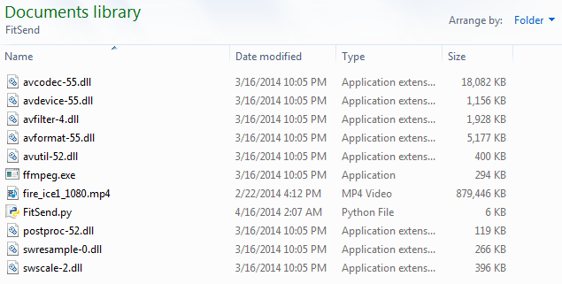

Figure 1